CrowSoft MySQL Script & Admin User

Contents

Log into MySQL Database Remotely 1

Create Database Schema 3

Adding a admin user 4

Run SQL script 5

# Log into MySQL Database Remotely

You will need MySQL Workbench if you would like to access the MySQL database from you desktop / home pc. Here is the link (It’s open source): <https://dev.mysql.com/downloads/workbench/>

Open MySQL Workbench, and go to Database, Connect to Database

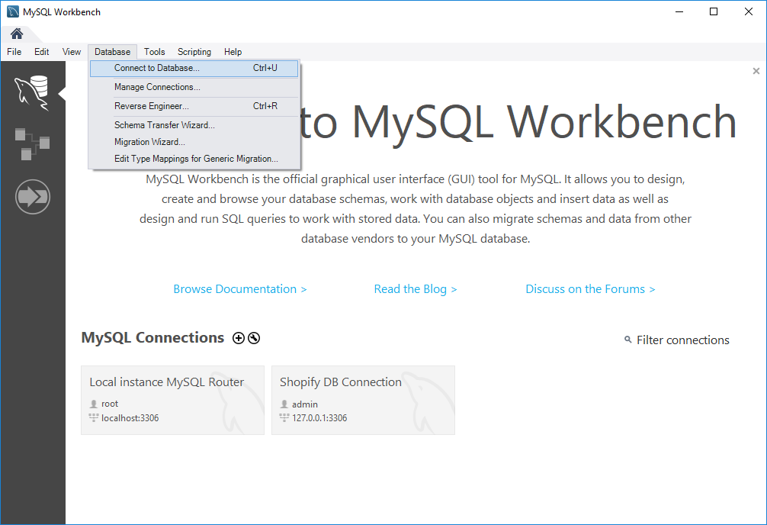

Click on Connection Method and select: Standard TCP/IP over SSH

Change the following settings

* SSH Hostname: 172.28.25.133:22
* SSH Username: devadmin
* SSH Password: refer to dev server password posted on Slack (You can store the password in Vault)
* MySQL Hostname: 172.28.25.133
* MySQL Server port: 3306
* Username: dbadmin
* Password: refer to dev server password posted on Slack (You can store the password in Vault)

Then click on OK

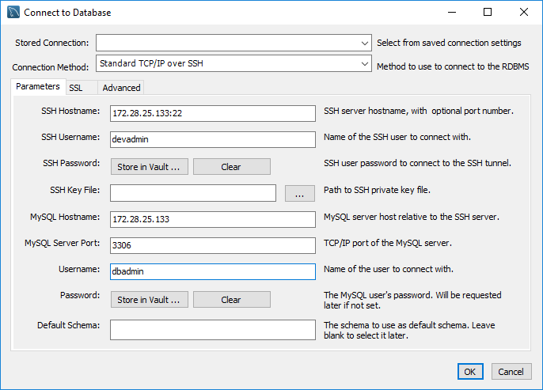

# Create Database Schema

Go to the Schemas tab, and right click, then click on Create Schema.

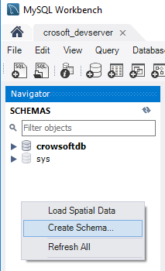

Type in database name in Name column and apply.

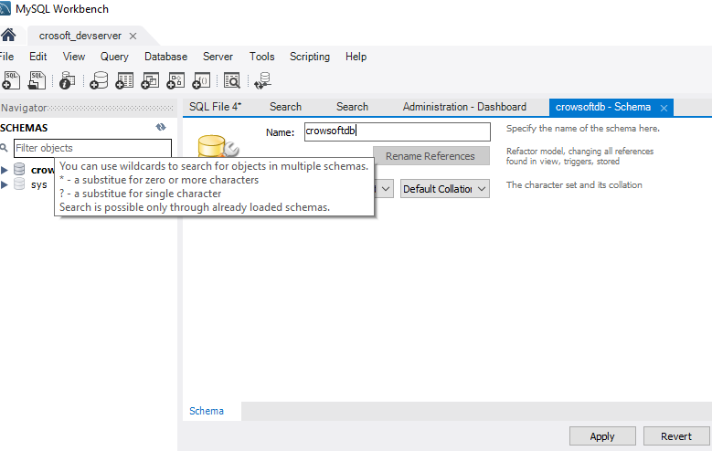

# Adding a admin user

Go to Server and click on Users and Privileges

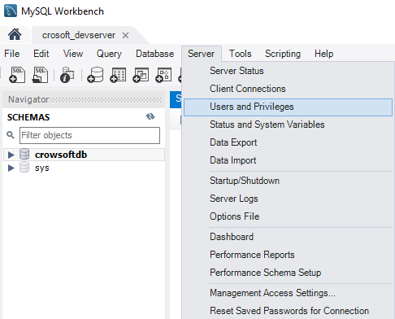

Click on Add Account, enter username and password.

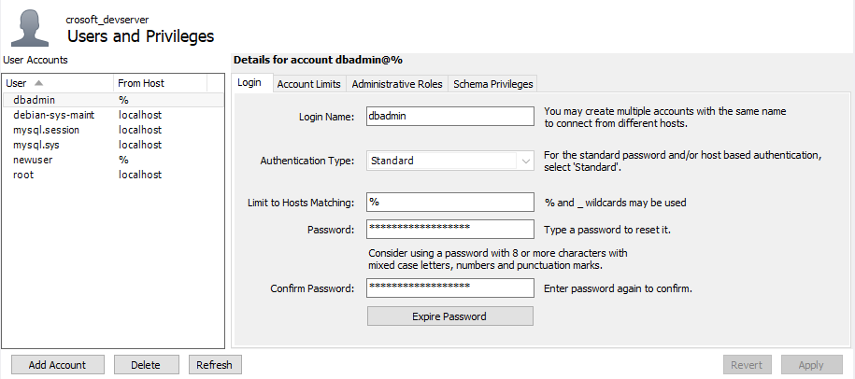

Click on Administrative Roles and all roles and all Global Privileges

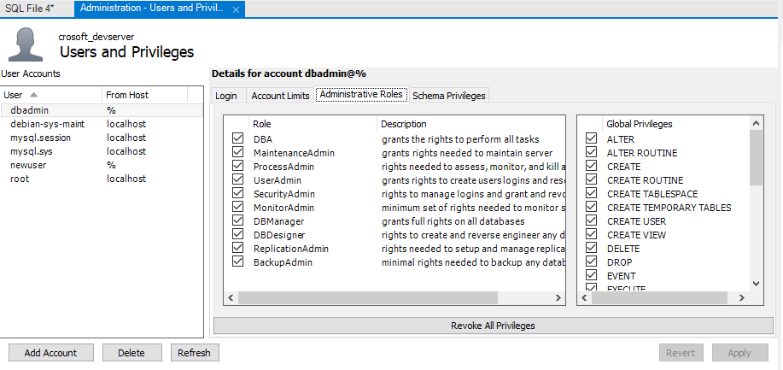

# Run SQL script

Click on Create a new SQL tab for executing queries Button.

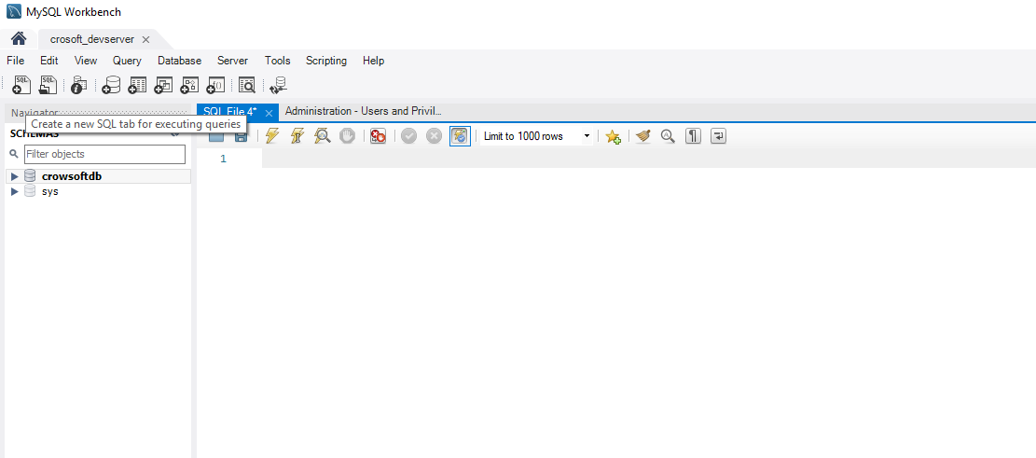

Copy and Paste SQL script (Find script in appendix) and click Execute Icon 

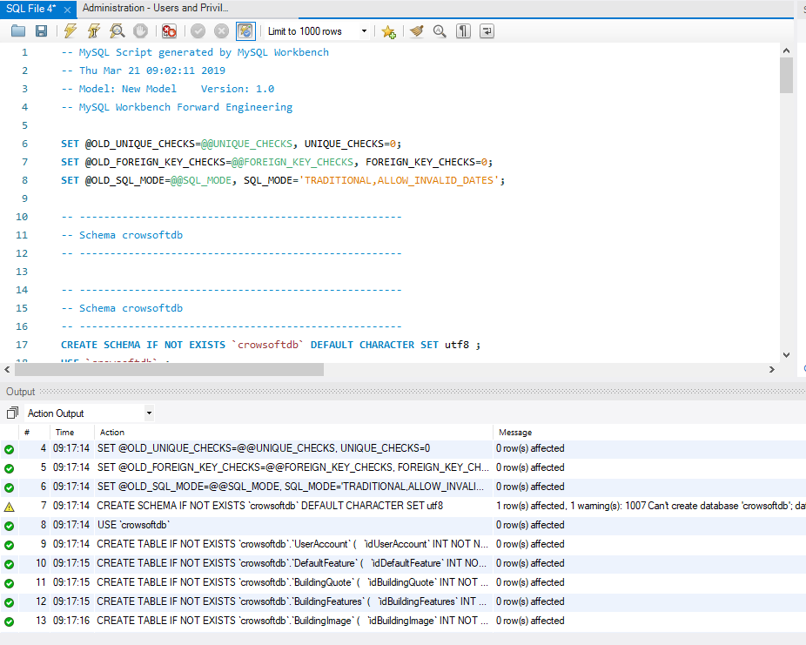

Right click on crowsoftdb and click Refresh All.

Open Tables and view tables.

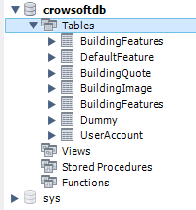

Appendix

-- MySQL Script generated by MySQL Workbench

-- Wed Apr 17 09:10:01 2019

-- Model: New Model Version: 1.0

-- MySQL Workbench Forward Engineering

SET @OLD_UNIQUE_CHECKS=@@UNIQUE_CHECKS, UNIQUE_CHECKS=0;

SET @OLD_FOREIGN_KEY_CHECKS=@@FOREIGN_KEY_CHECKS, FOREIGN_KEY_CHECKS=0;

SET @OLD_SQL_MODE=@@SQL_MODE, SQL_MODE='TRADITIONAL,ALLOW_INVALID_DATES';

-- -----------------------------------------------------

-- Schema mydb

-- -----------------------------------------------------

-- -----------------------------------------------------

-- Schema crowsoftdb

-- -----------------------------------------------------

DROP SCHEMA IF EXISTS `crowsoftdb` ;

-- -----------------------------------------------------

-- Schema crowsoftdb

-- -----------------------------------------------------

CREATE SCHEMA IF NOT EXISTS `crowsoftdb` DEFAULT CHARACTER SET latin1 ;

USE `crowsoftdb` ;

-- -----------------------------------------------------

-- Table `crowsoftdb`.`AspNetRoles`

-- -----------------------------------------------------

DROP TABLE IF EXISTS `crowsoftdb`.`AspNetRoles` ;

CREATE TABLE IF NOT EXISTS `crowsoftdb`.`AspNetRoles` (

`Id` VARCHAR(128) NOT NULL,

`Name` VARCHAR(256) NOT NULL,

PRIMARY KEY (`Id`))

ENGINE = InnoDB

DEFAULT CHARACTER SET = latin1;

-- -----------------------------------------------------

-- Table `crowsoftdb`.`AspNetUsers`

-- -----------------------------------------------------

DROP TABLE IF EXISTS `crowsoftdb`.`AspNetUsers` ;

CREATE TABLE IF NOT EXISTS `crowsoftdb`.`AspNetUsers` (

`Id` VARCHAR(128) NOT NULL,

`Email` VARCHAR(256) NULL DEFAULT NULL,

`EmailConfirmed` TINYINT(1) NOT NULL,

`PasswordHash` LONGTEXT NULL DEFAULT NULL,

`SecurityStamp` LONGTEXT NULL DEFAULT NULL,

`PhoneNumber` LONGTEXT NULL DEFAULT NULL,

`PhoneNumberConfirmed` TINYINT(1) NOT NULL,

`TwoFactorEnabled` TINYINT(1) NOT NULL,

`LockoutEnd` DATETIME NULL DEFAULT NULL,

`LockoutEnabled` TINYINT(1) NOT NULL,

`AccessFailedCount` INT(11) NOT NULL,

`UserName` VARCHAR(256) NOT NULL,

`ConcurrencyStamp` LONGTEXT NULL DEFAULT NULL,

`NormalizedEmail` VARCHAR(256) NULL DEFAULT NULL,

`NormalizedUserName` VARCHAR(256) NULL DEFAULT NULL,

PRIMARY KEY (`Id`))

ENGINE = InnoDB

DEFAULT CHARACTER SET = latin1;

-- -----------------------------------------------------

-- Table `crowsoftdb`.`AspNetUserClaims`

-- -----------------------------------------------------

DROP TABLE IF EXISTS `crowsoftdb`.`AspNetUserClaims` ;

CREATE TABLE IF NOT EXISTS `crowsoftdb`.`AspNetUserClaims` (

`Id` INT(11) NOT NULL AUTO_INCREMENT,

`UserId` VARCHAR(128) NOT NULL,

`ClaimType` LONGTEXT NULL DEFAULT NULL,

`ClaimValue` LONGTEXT NULL DEFAULT NULL,

PRIMARY KEY (`Id`),

UNIQUE INDEX `Id` (`Id` ASC),

INDEX `UserId` (`UserId` ASC),

CONSTRAINT `ApplicationUser_Claims`

FOREIGN KEY (`UserId`)

REFERENCES `crowsoftdb`.`AspNetUsers` (`Id`)

ON DELETE CASCADE

ON UPDATE NO ACTION)

ENGINE = InnoDB

DEFAULT CHARACTER SET = latin1;

-- -----------------------------------------------------

-- Table `crowsoftdb`.`AspNetUserLogins`

-- -----------------------------------------------------

DROP TABLE IF EXISTS `crowsoftdb`.`AspNetUserLogins` ;

CREATE TABLE IF NOT EXISTS `crowsoftdb`.`AspNetUserLogins` (

`LoginProvider` VARCHAR(128) NOT NULL,

`ProviderKey` VARCHAR(128) NOT NULL,

`UserId` VARCHAR(128) NOT NULL,

PRIMARY KEY (`LoginProvider`, `ProviderKey`, `UserId`),

INDEX `ApplicationUser_Logins` (`UserId` ASC),

CONSTRAINT `ApplicationUser_Logins`

FOREIGN KEY (`UserId`)

REFERENCES `crowsoftdb`.`AspNetUsers` (`Id`)

ON DELETE CASCADE

ON UPDATE NO ACTION)

ENGINE = InnoDB

DEFAULT CHARACTER SET = latin1;

-- -----------------------------------------------------

-- Table `crowsoftdb`.`AspNetUserRoles`

-- -----------------------------------------------------

DROP TABLE IF EXISTS `crowsoftdb`.`AspNetUserRoles` ;

CREATE TABLE IF NOT EXISTS `crowsoftdb`.`AspNetUserRoles` (

`UserId` VARCHAR(128) NOT NULL,

`RoleId` VARCHAR(128) NOT NULL,

PRIMARY KEY (`UserId`, `RoleId`),

INDEX `IdentityRole_Users` (`RoleId` ASC),

CONSTRAINT `ApplicationUser_Roles`

FOREIGN KEY (`UserId`)

REFERENCES `crowsoftdb`.`AspNetUsers` (`Id`)

ON DELETE CASCADE

ON UPDATE NO ACTION,

CONSTRAINT `IdentityRole_Users`

FOREIGN KEY (`RoleId`)

REFERENCES `crowsoftdb`.`AspNetRoles` (`Id`)

ON DELETE CASCADE

ON UPDATE NO ACTION)

ENGINE = InnoDB

DEFAULT CHARACTER SET = latin1;

-- -----------------------------------------------------

-- Table `crowsoftdb`.`UserAccount`

-- -----------------------------------------------------

DROP TABLE IF EXISTS `crowsoftdb`.`UserAccount` ;

CREATE TABLE IF NOT EXISTS `crowsoftdb`.`UserAccount` (

`idUserAccount` INT(11) NOT NULL AUTO_INCREMENT,

`EmailAddress` VARCHAR(150) NOT NULL COMMENT 'User email address used as username as well. ',

`FirstName` VARCHAR(60) NOT NULL,

`LastName` VARCHAR(60) NOT NULL,

`TelephoneNo` VARCHAR(45) NOT NULL,

`AddressLine` VARCHAR(150) NULL DEFAULT NULL,

`County` VARCHAR(45) NULL DEFAULT NULL,

`Country` VARCHAR(60) NULL DEFAULT NULL,

`EirCode` VARCHAR(20) NULL DEFAULT NULL,

`CompanyName` VARCHAR(45) NULL DEFAULT NULL,

`TypeUser` VARCHAR(15) NOT NULL,

`DateCreated` DATETIME NOT NULL DEFAULT CURRENT_TIMESTAMP,

`AspNetUserID` VARCHAR(128) NULL DEFAULT NULL,

PRIMARY KEY (`idUserAccount`),

UNIQUE INDEX `idUserAccount_UNIQUE` (`idUserAccount` ASC),

INDEX `fk_UserAccount_AspNetUsers1_idx` (`AspNetUserID` ASC),

CONSTRAINT `fk_UserAccount_AspNetUsers1`

FOREIGN KEY (`AspNetUserID`)

REFERENCES `crowsoftdb`.`AspNetUsers` (`Id`)

ON DELETE NO ACTION

ON UPDATE NO ACTION)

ENGINE = InnoDB

AUTO_INCREMENT = 25

DEFAULT CHARACTER SET = latin1;

-- -----------------------------------------------------

-- Table `crowsoftdb`.`BuildingQuote`

-- -----------------------------------------------------

DROP TABLE IF EXISTS `crowsoftdb`.`BuildingQuote` ;

CREATE TABLE IF NOT EXISTS `crowsoftdb`.`BuildingQuote` (

`idBuildingQuote` INT(11) NOT NULL AUTO_INCREMENT,

`UserAccount_idUserAccount` INT(11) NOT NULL,

`Description` VARCHAR(150) NOT NULL,

`MeasurementType` VARCHAR(25) NOT NULL,

`Height` INT(11) NOT NULL,

`Width` INT(11) NOT NULL,

`Depth` INT(11) NOT NULL,

`PurposeOfBuilding` VARCHAR(150) NULL DEFAULT NULL,

`BuildingSize` INT(11) NULL DEFAULT NULL,

`TotalCost` DECIMAL(12,2) NULL DEFAULT NULL,

`DateCreated` DATETIME NULL DEFAULT CURRENT_TIMESTAMP,

`Status` VARCHAR(10) NULL DEFAULT NULL,

`TimeFrame` INT(11) NULL DEFAULT NULL,

`DateUpdated` DATETIME NULL DEFAULT NULL,

`UpdatedById` INT(11) NULL DEFAULT NULL,

PRIMARY KEY (`idBuildingQuote`),

UNIQUE INDEX `idBuildingQuote_UNIQUE` (`idBuildingQuote` ASC),

INDEX `fk_BuildingQuote_UserAccount_idx` (`UserAccount_idUserAccount` ASC),

CONSTRAINT `fk_BuildingQuote_UserAccount`

FOREIGN KEY (`UserAccount_idUserAccount`)

REFERENCES `crowsoftdb`.`UserAccount` (`idUserAccount`)

ON DELETE NO ACTION

ON UPDATE NO ACTION)

ENGINE = InnoDB

DEFAULT CHARACTER SET = latin1;

-- -----------------------------------------------------

-- Table `crowsoftdb`.`DefaultFeature`

-- -----------------------------------------------------

DROP TABLE IF EXISTS `crowsoftdb`.`DefaultFeature` ;

CREATE TABLE IF NOT EXISTS `crowsoftdb`.`DefaultFeature` (

`idDefaultFeature` INT(11) NOT NULL AUTO_INCREMENT,

`Description` VARCHAR(100) NOT NULL,

`Measurement` VARCHAR(20) NOT NULL,

`UnitPrice` DECIMAL(8,2) NOT NULL,

`DefaultFeature` TINYINT(4) NULL DEFAULT NULL,

PRIMARY KEY (`idDefaultFeature`),

UNIQUE INDEX `idBuildingCost_UNIQUE` (`idDefaultFeature` ASC))

ENGINE = InnoDB

DEFAULT CHARACTER SET = latin1;

-- -----------------------------------------------------

-- Table `crowsoftdb`.`BuildingFeatures`

-- -----------------------------------------------------

DROP TABLE IF EXISTS `crowsoftdb`.`BuildingFeatures` ;

CREATE TABLE IF NOT EXISTS `crowsoftdb`.`BuildingFeatures` (

`idBuildingFeatures` INT(11) NOT NULL AUTO_INCREMENT,

`FeatureDescription` VARCHAR(100) NOT NULL,

`Comments` VARCHAR(150) NULL DEFAULT NULL,

`Quantity` DECIMAL(10,4) NOT NULL,

`UnitPrice` DECIMAL(10,2) NOT NULL,

`TotalCost` DECIMAL(12,2) NULL DEFAULT NULL,

`BuildingQuote_idBuildingQuote` INT(11) NOT NULL,

`DefaultFeature_idDefaultFeature` INT(11) NOT NULL,

PRIMARY KEY (`idBuildingFeatures`, `BuildingQuote_idBuildingQuote`, `DefaultFeature_idDefaultFeature`),

UNIQUE INDEX `idBuildingFeatures_UNIQUE` (`idBuildingFeatures` ASC),

INDEX `fk_BuildingFeatures_BuildingQuote1_idx` (`BuildingQuote_idBuildingQuote` ASC),

INDEX `fk_BuildingFeatures_DefaultFeature1_idx` (`DefaultFeature_idDefaultFeature` ASC),

CONSTRAINT `fk_BuildingFeatures_BuildingQuote1`

FOREIGN KEY (`BuildingQuote_idBuildingQuote`)

REFERENCES `crowsoftdb`.`BuildingQuote` (`idBuildingQuote`)

ON DELETE NO ACTION

ON UPDATE NO ACTION,

CONSTRAINT `fk_BuildingFeatures_DefaultFeature1`

FOREIGN KEY (`DefaultFeature_idDefaultFeature`)

REFERENCES `crowsoftdb`.`DefaultFeature` (`idDefaultFeature`)

ON DELETE NO ACTION

ON UPDATE NO ACTION)

ENGINE = InnoDB

DEFAULT CHARACTER SET = latin1;

-- -----------------------------------------------------

-- Table `crowsoftdb`.`BuildingImage`

-- -----------------------------------------------------

DROP TABLE IF EXISTS `crowsoftdb`.`BuildingImage` ;

CREATE TABLE IF NOT EXISTS `crowsoftdb`.`BuildingImage` (

`idBuildingImage` INT(11) NOT NULL AUTO_INCREMENT,

`Description` VARCHAR(150) NULL DEFAULT NULL,

`ImagePath` VARCHAR(200) NULL DEFAULT NULL,

`BuildingQuote_idBuildingQuote` INT(11) NOT NULL,

PRIMARY KEY (`idBuildingImage`, `BuildingQuote_idBuildingQuote`),

UNIQUE INDEX `idBuildingImage_UNIQUE` (`idBuildingImage` ASC),

INDEX `fk_BuildingImage_BuildingQuote1_idx` (`BuildingQuote_idBuildingQuote` ASC),

CONSTRAINT `fk_BuildingImage_BuildingQuote1`

FOREIGN KEY (`BuildingQuote_idBuildingQuote`)

REFERENCES `crowsoftdb`.`BuildingQuote` (`idBuildingQuote`)

ON DELETE NO ACTION

ON UPDATE NO ACTION)

ENGINE = InnoDB

DEFAULT CHARACTER SET = latin1;

-- -----------------------------------------------------

-- Table `crowsoftdb`.`Dummy`

-- -----------------------------------------------------

DROP TABLE IF EXISTS `crowsoftdb`.`Dummy` ;

CREATE TABLE IF NOT EXISTS `crowsoftdb`.`Dummy` (

`PersonID` TINYINT(3) UNSIGNED NOT NULL AUTO_INCREMENT,

`LastName` VARCHAR(255) NULL DEFAULT NULL,

`FirstName` VARCHAR(255) NULL DEFAULT NULL,

`Address` VARCHAR(255) NULL DEFAULT NULL,

`City` VARCHAR(255) NULL DEFAULT NULL,

PRIMARY KEY (`PersonID`))

ENGINE = InnoDB

AUTO_INCREMENT = 2

DEFAULT CHARACTER SET = utf8;

-- -----------------------------------------------------

-- Table `crowsoftdb`.`__EFMigrationsHistory`

-- -----------------------------------------------------

DROP TABLE IF EXISTS `crowsoftdb`.`__EFMigrationsHistory` ;

CREATE TABLE IF NOT EXISTS `crowsoftdb`.`__EFMigrationsHistory` (

`MigrationId` VARCHAR(150) CHARACTER SET 'utf8' NOT NULL,

`ProductVersion` VARCHAR(32) CHARACTER SET 'utf8' NOT NULL,

PRIMARY KEY (`MigrationId`))

ENGINE = InnoDB

DEFAULT CHARACTER SET = latin1;

SET SQL_MODE=@OLD_SQL_MODE;

SET FOREIGN_KEY_CHECKS=@OLD_FOREIGN_KEY_CHECKS;

SET UNIQUE_CHECKS=@OLD_UNIQUE_CHECKS;